- Purpose
This work instruction covers all of the features of RevTracker how to use it to create a redlined Excel workbook.

- Parent Documents
Document Number | Title
SOP5002 | RevTracker

- Child Documents
Document Number | Title
VA5002a | RevTracker General Guide

- Responsibility
  - It is the responsibility of the documentation specialist team to ensure that all RevTracker documentation is up-to-date.

- Provisioning and Permissions
  - RevTracker is a free Microsoft Office add-in that is available in the Microsoft Office Store.
  - RevTracker requires the user to sign-in and give read permissions to the user’s Microsoft account so that it can track the name in the changes.

- ChangeTracker
  - The RevTracker task pane must be open in order to track changes.
  - The built-in undo and redo features of Excel will be disabled while tracking changes. To undo or redo use the buttons in the RevTracker task pane shown in Figure 1.
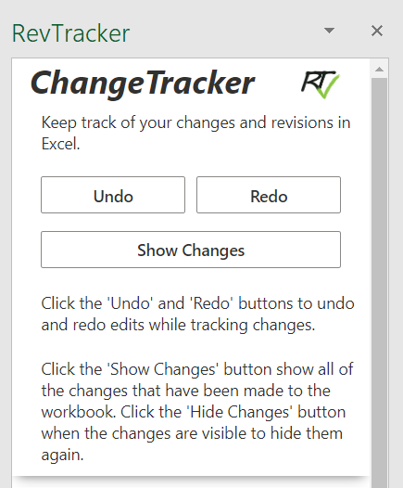
Figure 1. RevTracker task pane
- RevisionTracker
  - RevTracker allows you to segregate changes between revisions in a master redline. When a document revision is finalized and ready to be released select the revision number using the spin button shown in Figure 2.
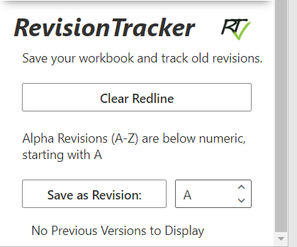
Figure 2. RevisionTracker Section
  - Click Save as Revision to save these settings under the specified revision.
  - Once saved under a revision these settings will no longer be accessible through the Show Changes button in Figure 1. To display the changes that of a specific revision click the Show Changes button next to the revision, shown in Figure 3.
  - To hide these changes, click the X button next the displayed revision.

- Releasing Document for Use
  - When a new revision is ready for release and the changes have been saved under the new revision, save two copies: a master redline and release version. The master redline will be used for all future revisions to keep document traceability throughout its lifetime.
  - In the release version click the Clear Redline button in the RevisionTracker section to remove all changes and revision settings.
    - NOTE: This cannot be undone so be sure that you have saved a master redline before confirming that you want to clear the redline.
  - After the redline has been cleared save the document and release it.

